New Pearson Support Website:
Access our NEW Ask Pearson Homepage where you will find helpful information and guides for Educators and Learners
Pearson Higher Education Support Home
Troubleshooting for MyLab, Mastering, Revel, and Pearson+ Platforms
Listed are some common settings that you will want to double-check if you are experiencing issues and error messages. The browser setting wizard link below has step by step directions for all browsers and operating systems.

Browser Settings Wizard

Try these common fixes:
1. Clear your browser's cache and cookies. Close your browser and retry.
2. Try a different browser (Google Chrome, Microsoft Edge and Firefox are preferred)
3. Disable your popup blocker, allow popups always.

*Below is a snapshot of where to locate your Internet Browser Settings
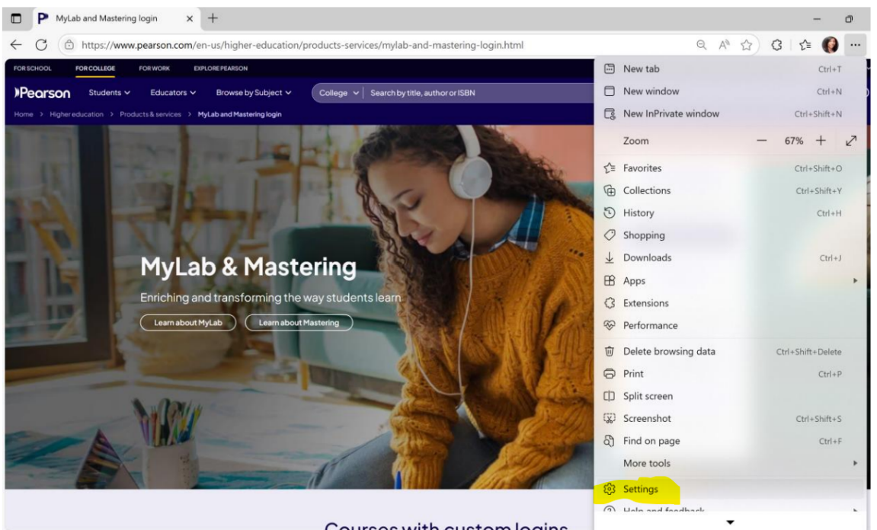

How To Reach Pearson Support
Students
Link to Support Site/ Submit Ticket: Contact Support (pearson.com)
Educators
Link to Support Site/ Submit Ticket: Contact Support (pearson.com)
Faculty Support Help: Book an appointment

